1. Blog Metadata (For CMS Fields)
- Title: Secure UX: How Small Interface Decisions Prevent Big Breaches
- Subtitle: Understanding how everyday UI patterns silently shape security outcomes.
- Category: Cybersecurity / Product Design
- Tags: Secure UX, Data Privacy, Human Factors, Design Systems, Engineering
- Publish Date: December 2025
- Slug: /blog/secure-ux-interface-decisions

2. Blog Body Content
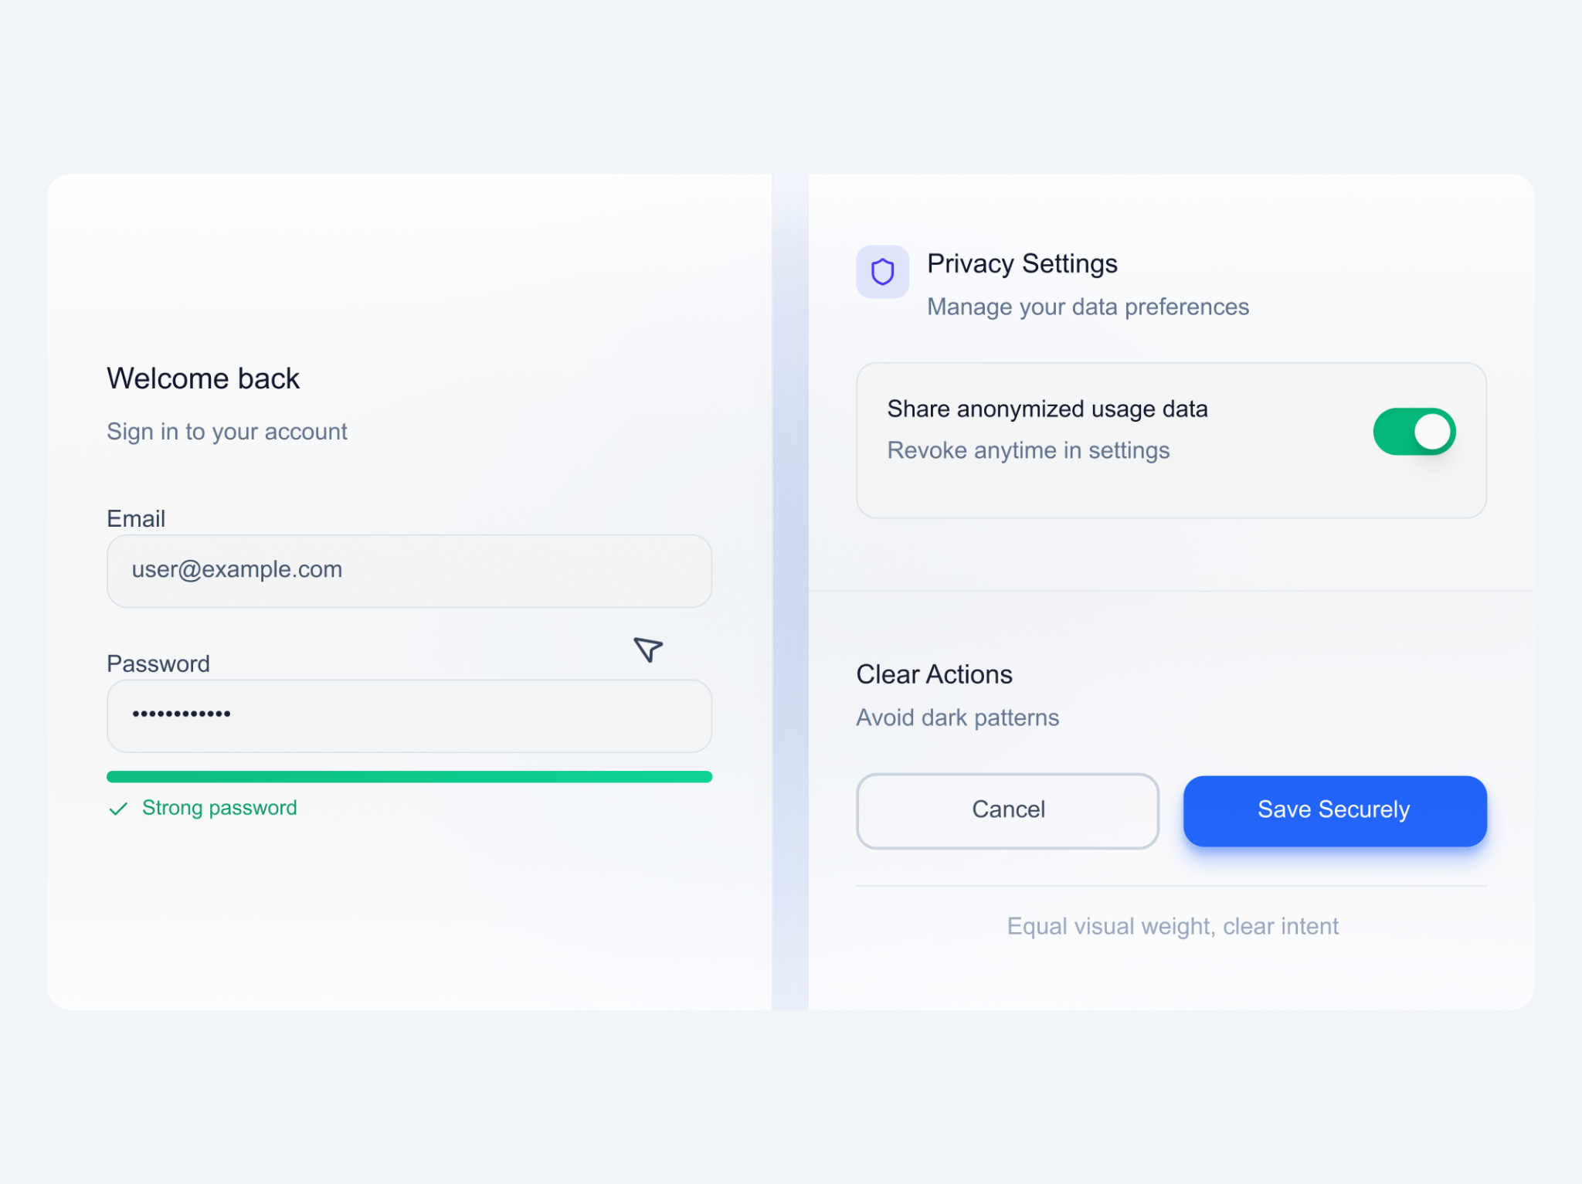
File Name: secure-ux-cover-bento-grid.png Alt Text: A clean, high-fidelity interface showing a secure login, a transparent permission toggle, and a clear button hierarchy arranged in a bento-grid layout. Caption (Optional): Interfaces that prioritize clarity reduce risk.

Introduction
Security breaches rarely begin with complex code exploits. Most originate from something far simpler — user confusion.
A hidden warning, a poorly explained permission, a vague Call to Action (CTA), or a predictable password pattern can unintentionally open doors for attackers. Designers often assume security is strictly a backend responsibility, but every UI we create shapes user behavior. And behavior is one of the biggest risk factors in cybersecurity.
This is where Secure UX comes in: design decisions that reduce human error and prevent vulnerabilities before they ever reach engineering.

The Problem: When UI Creates Risk
Human error contributes to over 80% of security incidents. But what triggers that error? Often, it is the interface itself.
When users trust the interface but the interface misguides them, security breaks. Examples of UI-driven vulnerabilities include:
- Users misunderstanding complex permission dialogs.
- Weak password creation due to unclear rules or feedback.
- Ambiguous "Delete" or "Share" actions.
- Privacy information hidden behind multiple clicks (progressive disclosure gone wrong).
- Misleading defaults that auto-select risky options.
As designers, our decisions directly influence whether users stay protected or unintentionally expose themselves.

The Deep Dive: 5 Layers of Secure UX

1. Clear Input & Validation Reduces Attack Surface
Good UX reduces mistakes, and fewer mistakes reduce vulnerabilities. Unclear forms lead to predictable passwords, typos, and data exposure — all exploitable by attackers.
Design Principles:
- Show password rules before the user starts typing.
- Give real-time strength & validation feedback (don't wait for "Submit").
- Avoid placeholder-only labels (this prevents credential mix-ups).
- Prevent autofill for high-risk inputs where sensitive data might be cached.

2. Permission Transparency Protects Users
Permissions are a high-risk area. When dialogs are vague, users grant access they don’t fully understand. Clarity builds trust and prevents oversharing.
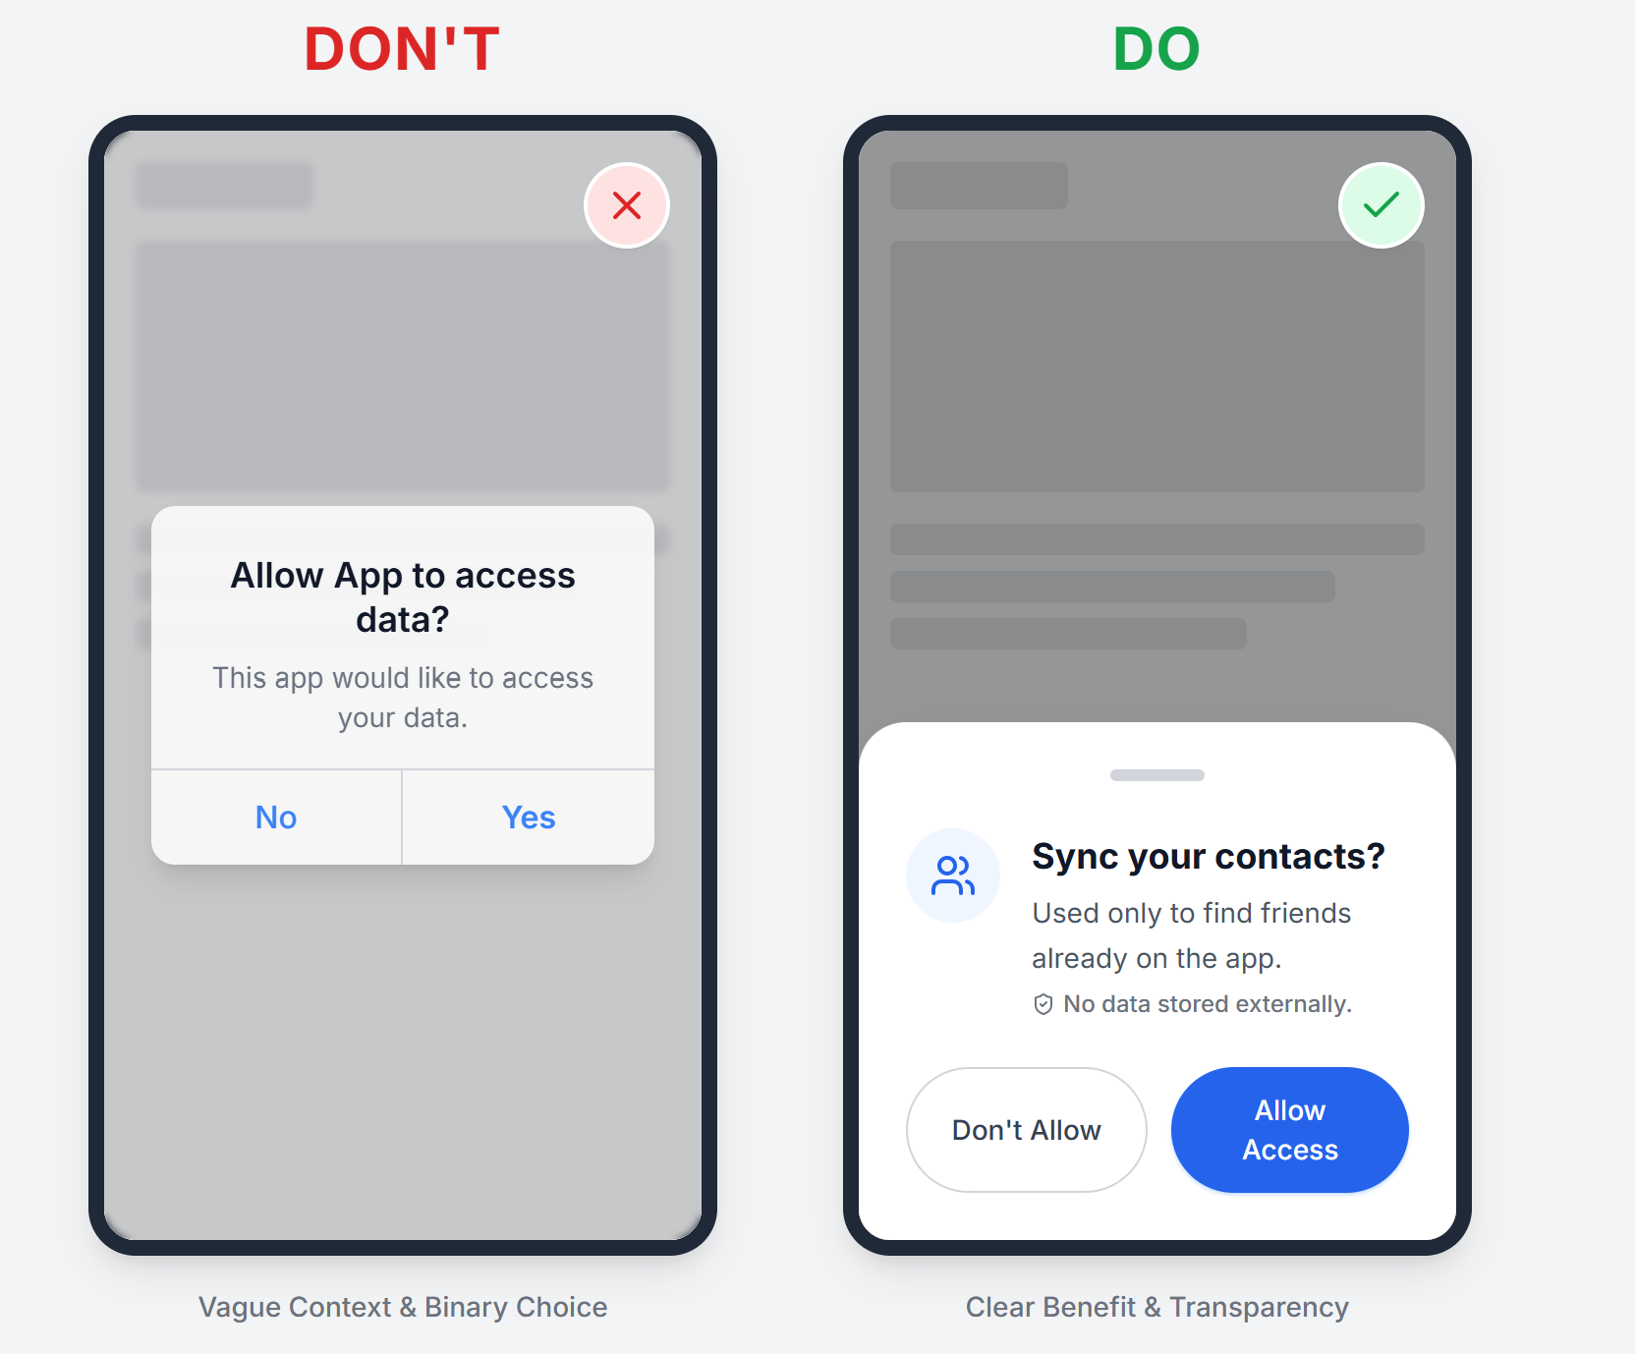
Prompt for this image: A side-by-side comparison. Left (Bad): A generic popup saying "Allow App to access data?" with just "Yes/No". Right (Good): A clean dialog saying "Allow App to sync your contacts?" with subtext "Used only to find friends. No data is stored externally." Alt Text: A comparison showing a vague permission request versus a transparent, context-rich permission request.
Design Principles:
- Explain why permission is needed.
- Show how long the access lasts.
- Avoid technical jargon.
- Highlight risk-level differences (e.g., “Visible only to you” vs. “Visible to your team”).

3. Avoid Dark Patterns That Create Security Blind Spots
Security breaks when users are manipulated or rushed into actions. Dark patterns don't just harm UX — they create legal, ethical, and security liabilities.
Avoid:
- Pre-selected checkboxes for sharing or consent.
- Misleading button hierarchies (making the "Cancel" button look like the "Confirm" button).
- Hidden cancellation options.

4. Safe Defaults > Clever Design
Most users never change their settings. Therefore, defaults define their level of protection. Secure defaults prevent harm even when users do nothing.
Safe Default Patterns:
- Strong password requirement: ON by default.
- Permissions: Revoked after session end or inactivity.
- Destructive actions: Require re-authentication (e.g., typing a password to delete a workspace).

5. Semantic Design Tokens Improve Security Consistency
Design systems don’t just create visual consistency; they enforce predictable security signaling.
Your token groups (e.g., text colors, border states, danger backgrounds) ensure alerts look the same everywhere. If a junior designer uses a "Brand Blue" for a warning, users might miss the risk.
Examples from a Secure Design System:
- StateDangerBg: For high-risk alerts (e.g., clear, distinct red/orange).
- ColorBorderDefault: Standard neutral borders.
- ColorTextWarning: Attention cues that don't blend into the background.
- StateSuccessBg: Verification cues.
Consistent semantic tokens lead to consistent user understanding, which leads to fewer risky mistakes. This is the foundational layer of Secure-by-Design systems.

The UX Perspective
"Security teams protect data. Designers protect decisions."
When interfaces are confusing, unclear, or misleading, users unintentionally create vulnerabilities. But when UX prioritizes transparency, predictability, and safety, even non-technical users can act securely without thinking about it.
Good UX reduces security incidents. Secure UX builds trust. Combined, they create safer products for everyone.

Conclusion
Every interface teaches users how to behave. Every behavior either reduces risk or increases it.
Secure UX isn’t about adding more warnings or clutter — it’s about crafting clear, predictable, thoughtful interactions that protect users from accidental harm. Security is not just a backend feature. It begins with the first click, and designers shape that moment.

